## Prerequisites

The following list defines the prerequisites for V-Manager.

* .Net Framework 4.0 & .Net Framework 3.5 SP1
* x64 Processor Architecture
* SQL Server 2008 R2
* SharePoint (MOSS) 2007

The following SharePoint Features containing shared assemblies are required for the V-Manager SharePoint user interface.

* + LLBLGen.3.5.12.507
  + Log4Net.1.2.11
  + Quartz.Net.2.1.2
  + Telerik.2012.1.411.35

## Installation

There are several components to V-Manager:

* Vmgr.Services – this is a Windows Service that operates V-Manager packages (*.vmgx).
* Vmgr.SharePoint – this is a SharePoint feature which provides a user interface for managing deployed V-Manager packages.
* Vmgr.VistualStudioAddin – this is a Visual Studio 2010 & 2012 add-in that facilitates project & item templates to help developers easily build V-Manager packages.

Installation media can be found in the contents of the Solutions folder:

* Solutions\Vmgr.Installer
* Solutions\Vmgr.Installer.x86
* Solutions\Vmgr.SharePoint

Also, there may be database related content in the Database folder (See Database later, and refer to addendums as appropriate).

### Installation

Executing the V-Manager installer through the provided Vmgr.Wix.msi creates and fully configures the V-Manager for the desired environment. Because there are several components included in V-Manager, the installer provides options for installation based upon intended use. For example: a development environment will likely require installation of the Pacakger, Visual Studio Addin, and Windows Service, whereas a production environment will likely just require installation of the Windows Service.

*Note: Installation of the SharePoint solution is achieved with a different installer found in Solutions\Vmgr.SharePoint.*

The following illustrations depict a production installation:

Welcome to the Dominion V-Manager (x64) Setup Wizard

Double-click the setup.exe file located in the Solutions\Vmgr.Installer directory.

Click “Next >” to proceed with the installation.

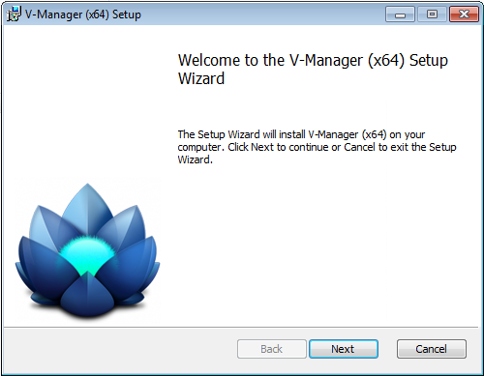

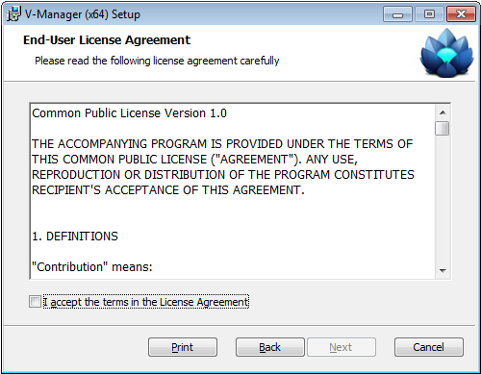

Select Installation Folder

Choose which components are required for the installation.

Choose a folder where Dominion V-Manager (x64) will be installed. Note: on an x64 environment, the default path provided is acceptable.

Click “Next >” to proceed with the installation.

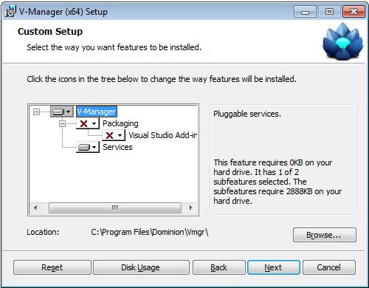

Vmgr Service Credentials

Provide the Username and Password required for the service to operate with. Note: this username should be a service account and that account should have read/write privileges to the database catalog (see Database later).

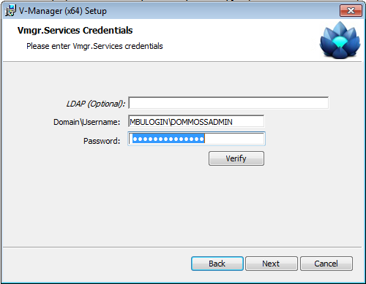

VMGR Database Connection

Provide the SQL Server instance name that the V-Manager Windows Service will user to connect to the database. Upon installation, this value will be used to re-write the service application configuration connection string.

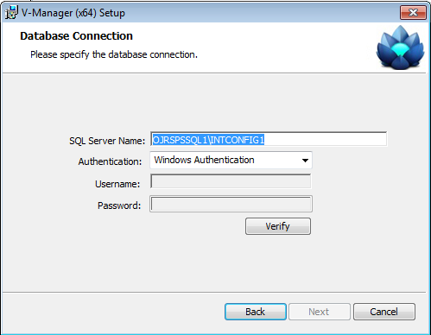

Confirm Installation

Click ‘Next >”.

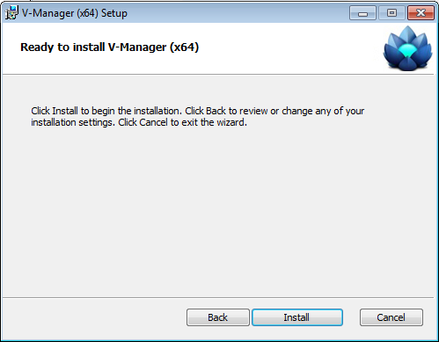

Installing Dominion V-Manager

Wait for the installation to complete.

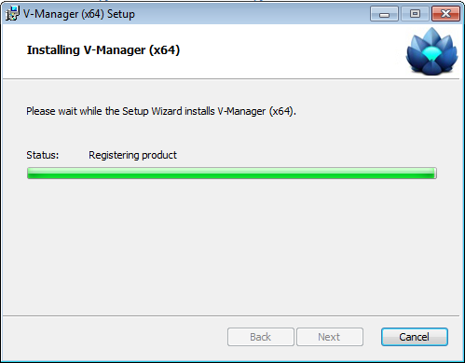

Installation Complete

Click “Close”.

### Configuration – Vmgr.Services

Configuration File

Once the Vmgr.Services Windows Service is installed, additional changes to the configuration file may be necessary. If during installation, the default installation path was used, the configuration file should be found in the Vmgr.Services folder (e.g. C:\Program Files\Dominion\Vmgr\Vmgr.Services\ Vmgr.Services.exe.config).

<?xml version="1.0"?>

<configuration>

<configSections>

<section name="log4net" type="log4net.Config.Log4NetConfigurationSectionHandler, log4net, Version=1.2.11.0, Culture=neutral, PublicKeyToken=669e0ddf0bb1aa2a" />

<section name="sqlServerCatalogNameOverwrites" type="System.Configuration.NameValueSectionHandler, System, Version=1.0.5000.0, Culture=neutral, PublicKeyToken=b77a5c561934e089" />

<section name="pluginAssemblyExclusions" type="System.Configuration.NameValueSectionHandler, System, Version=1.0.5000.0, Culture=neutral, PublicKeyToken=b77a5c561934e089" />

</configSections>

<sqlServerCatalogNameOverwrites>

</sqlServerCatalogNameOverwrites>

<appSettings>

<add key="VmgrConnectionString" value="data source= INBSPSQLW812T\INTCONTENT1;initial catalog=DOM_Config;integrated security=SSPI;persist security info=False;packet size=4096"/>

</appSettings>

<pluginAssemblyExclusions>

<add key="Microsoft.SharePoint" value="Microsoft.SharePoint, Version=12.0.0.0, Culture=neutral, PublicKeyToken=71e9bce111e9429c" />

</pluginAssemblyExclusions>

<system.diagnostics>

<switches>

<add name="SqlServerDQE" value="4" />

<add name="ORMGeneral" value="4" />

<add name="ORMStateManagement" value="4" />

<add name="ORMPersistenceExecution" value="4" />

</switches>

<sources>

<source name="System.ServiceModel"

switchValue="Information, ActivityTracing"

propagateActivity="true">

<listeners>

<add name="traceListener"

type="System.Diagnostics.XmlWriterTraceListener"

initializeData="c:\Traces.svclog" />

</listeners>

</source>

</sources>

</system.diagnostics>

</configuration>

Note: <system.diagnostics> can be removed to increase performance.

Note: to exclude certain assemblies from being dynamically loaded by the Vmgr.Services Windows Service, add additional keys to the configuration section <pluginAssemblyExclusions>.

Note: If the database schema is deployed to a Database catalog other than DOM_Config, a new key will be required in the <sqlServerCatalogNameOverwrites> configuration section to allow the system to properly alias SQL Server queries.

### Installation – Vmgr.SharePoint

Executing the Vmgr.SharePoint through the provided setup.exe deploys a Web-Scoped feature to the SharePoint Web Application specified during installation. This feature, once activated against a sub-site, will provide a user interface for uploading V-Manager packages (*.vmgx) to the targeted server where the Vmgr.Services Window Service is running.

V-Manager SharePoint Feature

Double-click the setup.exe file located in the Solutions\Vmgr.SharePoint directory.

Click “Next” to proceed with the installation.

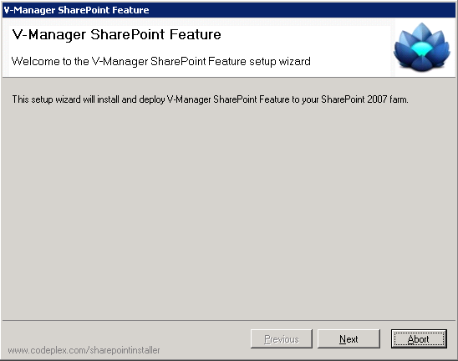

System Check

Verify that all line items during the system check receive a green check mark.

Click “Next” to proceed with the installation.

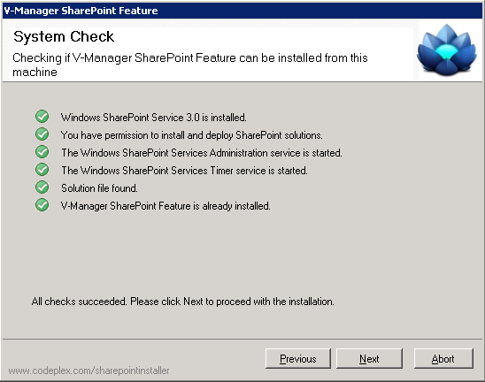

Farm Deployment Targets

Check the box or boxes where the V-Manager SharePoint Feature is to be deployed.

Click “Next” to proceed with the installation.

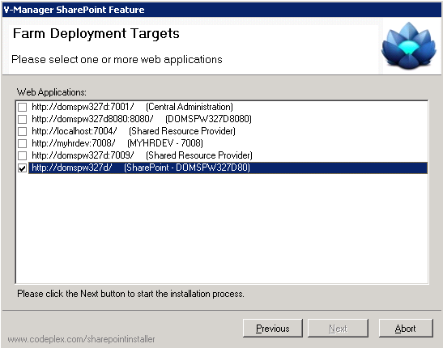

Installing

Wait for the installation to complete.

Click “Next” to proceed with the installation.

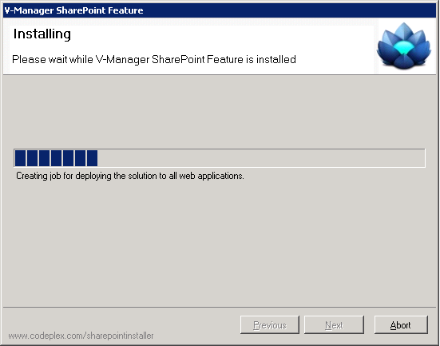

Installation Successfully Completed

Click “Close”.

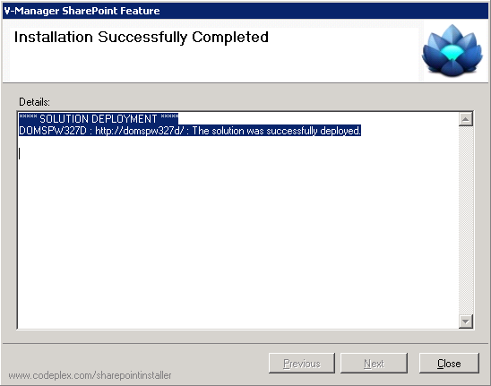

### Configuration – Vmgr.SharePoint

Configuration File

The V-Manager SharePoint Feature depends on several configuration file changes made to the web.config of the SharePoint Web Application where the solution was deployed. Since the V-Manager SharePoint Feature targets MOSS 2007, the web.config must be enhanced to support ASP.Net Ajax content and Telerik version 2012.1.411.35 controls.

<configuration>

<configSections>

...

<sectionGroup name="system.web.extensions" type="System.Web.Configuration.SystemWebExtensionsSectionGroup, System.Web.Extensions, Version=3.5.0.0, Culture=neutral, PublicKeyToken=31BF3856AD364E35">

<sectionGroup name="scripting" type="System.Web.Configuration.ScriptingSectionGroup, System.Web.Extensions, Version=3.5.0.0, Culture=neutral, PublicKeyToken=31BF3856AD364E35">

<section name="scriptResourceHandler" type="System.Web.Configuration.ScriptingScriptResourceHandlerSection, System.Web.Extensions, Version=3.5.0.0, Culture=neutral, PublicKeyToken=31BF3856AD364E35" requirePermission="false" allowDefinition="MachineToApplication" />

<sectionGroup name="webServices" type="System.Web.Configuration.ScriptingWebServicesSectionGroup, System.Web.Extensions, Version=3.5.0.0, Culture=neutral, PublicKeyToken=31BF3856AD364E35">

<section name="jsonSerialization" type="System.Web.Configuration.ScriptingJsonSerializationSection, System.Web.Extensions, Version=3.5.0.0, Culture=neutral, PublicKeyToken=31BF3856AD364E35" requirePermission="false" allowDefinition="Everywhere" />

<section name="profileService" type="System.Web.Configuration.ScriptingProfileServiceSection, System.Web.Extensions, Version=3.5.0.0, Culture=neutral, PublicKeyToken=31BF3856AD364E35" requirePermission="false" allowDefinition="MachineToApplication" />

<section name="authenticationService" type="System.Web.Configuration.ScriptingAuthenticationServiceSection, System.Web.Extensions, Version=3.5.0.0, Culture=neutral, PublicKeyToken=31BF3856AD364E35" requirePermission="false" allowDefinition="MachineToApplication" />

<section name="roleService" type="System.Web.Configuration.ScriptingRoleServiceSection, System.Web.Extensions, Version=3.5.0.0, Culture=neutral, PublicKeyToken=31BF3856AD364E35" requirePermission="false" allowDefinition="MachineToApplication" />

</sectionGroup>

</sectionGroup>

</sectionGroup>

<section name="sqlServerCatalogNameOverwrites" type="System.Configuration.NameValueSectionHandler, System, Version=1.0.5000.0, Culture=neutral, PublicKeyToken=b77a5c561934e089" />

...

<sqlServerCatalogNameOverwrites>

</sqlServerCatalogNameOverwrites>

...

<httpHandlers>

...

<remove verb="*" path="*.asmx" />

<add verb="*" path="*.asmx" validate="false" type="System.Web.Script.Services.ScriptHandlerFactory, System.Web.Extensions, Version=3.5.0.0, Culture=neutral, PublicKeyToken=31BF3856AD364E35" />

<add verb="*" path="*_AppService.axd" validate="false" type="System.Web.Script.Services.ScriptHandlerFactory, System.Web.Extensions, Version=3.5.0.0, Culture=neutral, PublicKeyToken=31BF3856AD364E35" />

<add verb="GET,HEAD" path="ScriptResource.axd" type="System.Web.Handlers.ScriptResourceHandler, System.Web.Extensions, Version=3.5.0.0, Culture=neutral, PublicKeyToken=31BF3856AD364E35" validate="false" />

<add verb="*" path="Telerik.Web.UI.WebResource.axd" type="Telerik.Web.UI.WebResource, Telerik.Web.UI, Version=2012.1.411.35, Culture=neutral, PublicKeyToken=121fae78165ba3d4" />

<add path="Telerik.Web.UI.DialogHandler.axd" type="Telerik.Web.UI.DialogHandler, Telerik.Web.UI, Version=2012.1.411.35, Culture=neutral, PublicKeyToken=121fae78165ba3d4" verb="*" validate="false" />

<add path="Telerik.RadUploadProgressHandler.ashx" type="Telerik.Web.UI.RadUploadProgressHandler, Telerik.Web.UI, Version=2012.1.411.35, Culture=neutral, PublicKeyToken=121fae78165ba3d4" verb="*" validate="false" />

<add path="ChartImage.axd" verb="*" type="Telerik.Web.UI.ChartHttpHandler, Telerik.Web.UI, Version=2012.1.411.35, Culture=neutral, PublicKeyToken=121fae78165ba3d4" validate="false" />

...

</httpHandlers>

<httpModules>

<clear />

...

<add name="ScriptModule" type="System.Web.Handlers.ScriptModule, System.Web.Extensions, Version=3.5.0.0, Culture=neutral, PublicKeyToken=31BF3856AD364E35" />

<add name="RadUploadModule" type="Telerik.Web.UI.RadUploadHttpModule, Telerik.Web.UI, Version=2012.1.411.35, Culture=neutral, PublicKeyToken=121fae78165ba3d4" />

...

</httpModules>

<compilation batch="false" debug="false">

<assemblies>

...

<add assembly="System.Core, Version=3.5.0.0, Culture=neutral, PublicKeyToken=B77A5C561934E089" />

<add assembly="System.Web.Extensions, Version=3.5.0.0, Culture=neutral, PublicKeyToken=31BF3856AD364E35" />

<add assembly="System.Data.DataSetExtensions, Version=3.5.0.0, Culture=neutral, PublicKeyToken=B77A5C561934E089" />

<add assembly="System.Xml.Linq, Version=3.5.0.0, Culture=neutral, PublicKeyToken=B77A5C561934E089" />

...

</assemblies>

<pages enableSessionState="true" enableViewState="true" enableViewStateMac="true" validateRequest="false" pageParserFilterType="Microsoft.SharePoint.ApplicationRuntime.SPPageParserFilter, Microsoft.SharePoint, Version=12.0.0.0, Culture=neutral, PublicKeyToken=71e9bce111e9429c" asyncTimeout="7">

...

<controls>

<add tagPrefix="asp" namespace="System.Web.UI" assembly="System.Web.Extensions, Version=3.5.0.0, Culture=neutral, PublicKeyToken=31bf3856ad364e35" />

<add tagPrefix="asp" namespace="System.Web.UI.WebControls" assembly="System.Web.Extensions, Version=3.5.0.0, Culture=neutral, PublicKeyToken=31bf3856ad364e35" />

<add tagPrefix="telerik" namespace="Telerik.Web.UI" assembly="Telerik.Web.UI, Version=2012.1.411.35, Culture=neutral, PublicKeyToken=121fae78165ba3d4" />

</controls>

</pages>

<runtime>

<assemblyBinding xmlns="urn:schemas-microsoft-com:asm.v1">

<dependentAssembly>

<assemblyIdentity name="System.Web.Extensions" publicKeyToken="31bf3856ad364e35" />

<bindingRedirect oldVersion="1.0.0.0-1.1.0.0" newVersion="3.5.0.0" />

</dependentAssembly>

<dependentAssembly>

<assemblyIdentity name="System.Web.Extensions.Design" publicKeyToken="31bf3856ad364e35" />

<bindingRedirect oldVersion="1.0.0.0-1.1.0.0" newVersion="3.5.0.0" />

</dependentAssembly>

...

</configuration>

In addition, the machine.config file located in the Framework64 folder (e.g. C:\WINDOWS\Microsoft.NET\Framework64\v2.0.50727\CONFIG\machine.config) must be updated to include the VmgrConnectionString key in the appSettings configuration section.

<configuration>

...

<appSettings>

<add key="VmgrConnectionString" value="data source= INBSPSQLW812T\INTCONTENT1;initial catalog=DOM_Config;integrated security=SSPI;persist security info=False;packet size=4096"/>

</appSettings>

**Important**: Once the configuration is defined, the App_Data folder within the IIS web application where V-Manager is deployed must be set to have “Authenticated Users”. This account requires read/modify NTFS permissions to be set. This requirement allows the Telerik RadUpload control to correctly function, as files are temporarily uploaded to the App_Data\TemporaryFolder location.

V-Manager Feature Activation

The V-Manager SharePoint feature is web-scoped, and therefore activated against a Blank Site Template of a SharePoint sub-site.

**Important**: The feature, upon activation, replaces the default page of the site, and replaces all quick launch links with links required by the application. For this reason, the SharePoint Feature should only be activated against a sub-site, and not the root site of a site collection.

**Important**: Activation requires the following activation dependencies. These dependencies may r may not already be activated for the site collection where V-Manager is to be activated.

* + LLBLGen.3.5.12.507
  + Log4Net.1.2.11
  + Quartz.Net.2.1.2
  + Telerik.2012.1.411.35

**Important**: The V-Manager SharePoint Feature contains *.asmx and *.ashx files. These files are typically blocked from Central Admin. They must be removed by using CA > Operations > Blocked File Types. Choose the correct web application from the drop-down list, then remove the two file extensions from the list, and click OK.

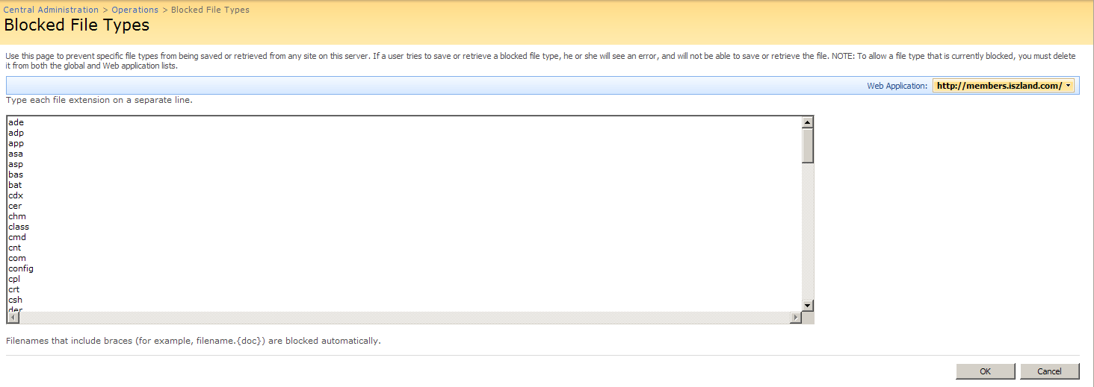

Navigate to the sub-site of the SharePoint Web Application where V-Manager was deployed.

Navigate to Site Settings > Site Administration > Site Features

Click the “Activate” button next to the V-Manager SharePoint Feature

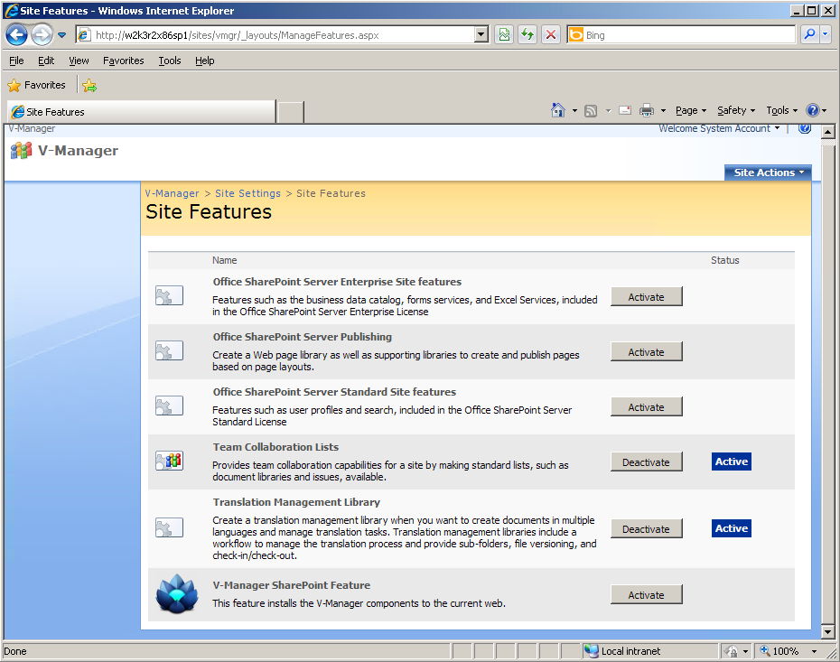

Once the V-Manager SharePoint Feature is activated, you may use the bread crumbs to navigate back to the default page of the sub-site to view the Dashboard.

Note: the application may redirect you to Server Selection if a server had not previously been selected. If so, pick a server where the V-Manager Windows Service was installed.

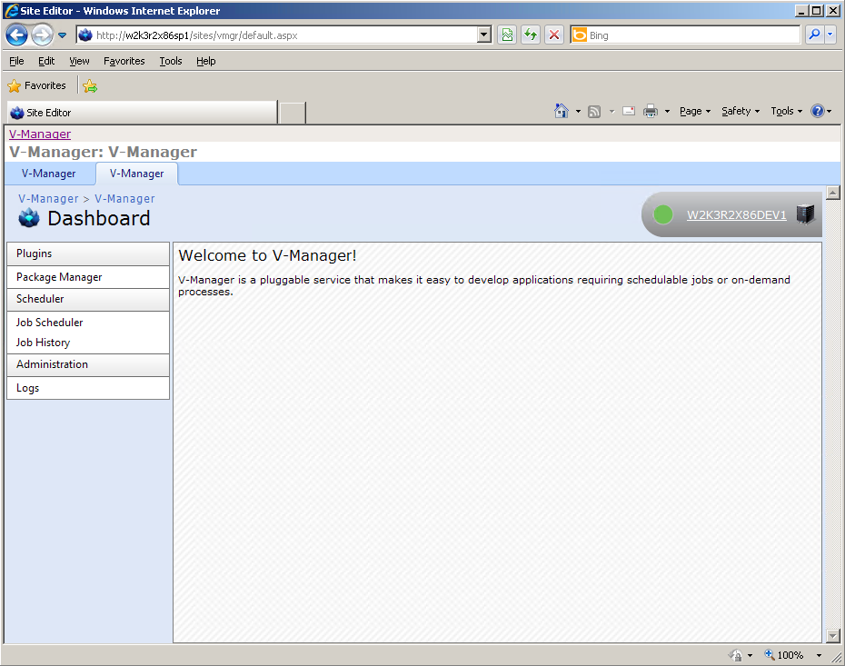

### Configuration – Database

The following scripts must be executed against the DOM_Config database in the order specified:

* VMGR_FULL_SCHEMA.sql
* VMGR_DEFAULT_DATA_DOM_CONFIG.sql

Note: additional database catalog configuration may be required, such as logon users and permissions for the ‘vmg’ schema.